DIGT2107: Practice of Software Development

Project Deliverable 2.2:
Mid Project Report Submission

Project Name:
SmartBudget – Personal Finance Tracker

Team Number:
Team #3

Team Members:
Mohsen Pasdar, Muhammed Ahmed, Alia Hagi-Dhaffe

Date:
November 30, 2025

Table of Contents
1 Introduction 1
2 Updated Requirements 1
2.1 Functional Requirements 1
2.2 Non-Functional Requirements 2
3 Updated Use Cases 2
3.1 Actors 2
3.2 Use-Case Diagram 2
3.3 Use-Case Descriptions 3
3.3.1 UC-1: Record Transaction 3
3.3.2 UC-2: Amend Transaction 3
3.3.3 UC-3: View & Filter Transactions 4
3.3.4 UC-4: Set Monthly Budget 4
3.3.5 UC-5: View Summary Report 4
3.3.6 UC-6: Receive Overspending Alert 4
4 Updated User Stories 5
4.1 User Story 1: Record a Transaction 5
4.2 User Story 2: Edit or Delete a Transaction 5
4.3 User Story 3: View and Filter Transactions 6
4.4 User Story 4: Set a Monthly Budget 6
4.5 User Story 5: Receive Overspending Alerts 6
4.6 User Story 6: View Monthly Summary 7
4.7 User Story 7: View Spending Chart 7
4.8 User Story 8: Load Saved Data on Startup 8
5 Test Plan 8
5.1 Testing Objectives and Scope 8
5.2 Testing Approach (Unit Testing Focus for Iteration 3) 9
5.3 Requirement-to-Test Case Traceability Matrix 9
5.4 Mapping to Use Cases and User Stories 12
5.5 Detailed Test Case Descriptions 13
5.5.1 TC-001 14
5.5.2 TC-002 14
5.5.3 TC-003 15
5.5.4 TC-004 15
5.5.5 TC-005 16
5.5.6 TC-006 16
5.5.7 TC-007 17
5.5.8 TC-008 17
5.5.9 TC-009 18
5.5.10 TC-010 18
5.5.11 TC-011 18
5.5.12 TC-012 19
5.5.13 TC-013 19
5.5.14 TC-014 20
5.5.15 TC-015 20
5.5.16 TC-016 20
5.5.17 TC-017 21
5.5.18 TC-018 21
5.5.19 TC-019 22
5.5.20 TC-020 22
5.5.21 TC-021 23
5.5.22 TC-022 23
5.5.23 TC-023 23
5.5.24 TC-024 24
5.5.25 TC-025 24
5.5.26 TC-026 25
5.5.27 TC-027 25
5.5.28 TC-028 26
5.5.29 TC-029 26
5.5.30 TC-030. 26
5.5.31 TC-031 27
5.5.32 TC-032 27
6 User Manual 28
6.1 Introduction 28
6.2 Getting Started 28
6.2.1 System Requirements 28
6.2.2 First Launch 28
6.3 Navigating SmartBudget 29
6.4 Transactions 29
6.4.1 Adding a Transaction 29
6.4.2 Editing a Transaction 29
6.4.3 Deleting a Transaction 29
6.4.4 Viewing Transactions 30
6.4.5 Filtering Transactions 30
6.5 Budgets 30
6.5.1 Setting a Budget 30
6.6 Overspending Alerts 30
6.7 Reports 30
6.7.1 Summary Report 30
6.7.2 Category Spending Chart 31
6.8 Data Persistence 31
6.9 Offline Mode and Privacy 31
6.10 Performance & Responsiveness 31
6.11 Cross-Platform Support 31
6.12 Maintenance & Updates 31
6.13 Frequently Asked Questions 31
6.14 Summary 32
7 Prototype Overview 32
7.1 Purpose of the Prototype 32
7.2 Feature Coverage 33
7.2.1 Record, Edit, and Delete Transactions (FR1) 33
7.2.2 Viewing and Filtering Transactions (FR2) 33
7.2.3 Monthly Budgets and Alerts (FR3) 33
7.2.4 Summary and Charts (FR4) 33
7.3 Navigation Flow 33
7.4 Prototype Screenshots 34
7.4.1 Dashboard view 34
7.4.2 Add Transaction form 35
7.4.3 Edit Transaction form 35
7.4.4 Delete Transaction form 36
7.4.5 Filters and search UI 36
7.4.6 Budgets screen and Overspending alert sample 37
7.4.7 Add Budget form 37
7.4.8 Edit Budget form 38
7.4.9 Monthly summary with chart 39
7.5 Alignment With Requirements and Testing 39
7.6 Prototype Link 40
8 Code Repository and Branching Strategy 40
8.1 Repository Link: 40
8.2 Branching Strategy: 40
9 Iteration Plan and Backlog 40
9.1 Iteration Plan 41
9.1.1 Iteration 1 (Weeks 1–2 – Vision and Planning) 41
9.1.2 Iteration 2 (Weeks 3–5 – Requirements and Use Cases) 41
9.1.3 Iteration 3 (Weeks 6–9 –Testing Document) 41
9.1.4 Iteration 4 (Weeks 10–12 – Mid-Project Peer Review) 41
9.1.5 Iteration 5 (Weeks 1–2 – Advanced Software Design) 41
9.1.6 Iteration 6 (Weeks 3–4 – GUI Development and Testing) 41
9.1.7 Iteration 7 (Weeks 6–9 – Refactoring and Implementation) 41
9.1.8 Iteration 8 (Weeks 10–11 – Final Testing and Documentation) 41
9.1.9 Iteration 9 (Week 12 – Block Week – Final Presentation and Submission) 41
9.2 Updated Backlog 42
10 Conclusion 42

Introduction
This document represents Deliverable 2.2 for the DIGT2107: Practice of Software Development course. As part of Iteration 2.2, we bring together the updated requirements, the complete testing documentation, the full user manual, and the overview of the SmartBudget prototype. This deliverable builds on the earlier work completed in Deliverables 1.1, 1.2, and 2.1, where we defined the project vision, described the system requirements, created detailed use cases and user stories, and prepared the initial testing plan.
The main goal of this deliverable is to present a clear and organized view of the project at the mid-point of development. We refined the functional and non-functional requirements based on feedback, improved the use cases, and expanded the testing documentation with full traceability. This ensures that each requirement is linked to a corresponding test case and prepared for validation once implementation begins.
We also included the UX/UI prototype created in Figma. This prototype is not a Java desktop application and does not include any backend logic. Instead, it serves as a visual guide for how the final system should look and behave. It shows the layout, navigation structure, and user flows for key features such as recording transactions, managing budgets, and viewing reports. This design will guide the upcoming development work and help keep the implementation aligned with the requirements.
This document is structured to show the progress made up to this point. It begins with the updated requirements and use cases, followed by the complete testing document. It then presents the user manual and the prototype overview. Together, these components form a solid foundation for the next development stages, where we will begin implementing the backend, JavaFX interface, building core features, and executing test cases as the system evolves.

Updated Requirements

Functional Requirements
- FR1 – Transactions: The system must let the user record, edit, and delete income and expense transactions (amount, date, category, optional note), and persist them locally so they remain available across sessions.
- FR2 – Browsing & Filters: The system must let the user view transactions and apply filters (e.g., by date range and category) to review specific spending.
- FR3 – Budgets & Alerts: The system must let the user set a monthly spending limit per category and notify the user when spending reaches or exceeds that limit.
- FR4 – Summaries & Charts: The system must provide a period summary (income, expenses, balance) and at least one visual breakdown of spending by category.

Non-Functional Requirements
- Usability: The system should present a simple, consistent JavaFX interface with clear labels, readable fonts, and sensible navigation between Transactions, Budgets, and Reports.
- Performance: The system should load typical datasets quickly and remain responsive during common operations.
- Reliability: The system should save changes immediately to local storage to minimize data loss and handle invalid inputs gracefully with clear feedback.
- Privacy/Offline: The system should operate fully offline and avoid sending data over a network.
- Portability: The system should run on Windows, macOS, and Linux with a supported Java runtime.
- Maintainability: The system should adopt a modular structure (e.g., MVC) and include unit tests for core business logic to enable straightforward updates.

Updated Use Cases

Actors
- User – an individual tracking personal finance.

Use-Case Diagram

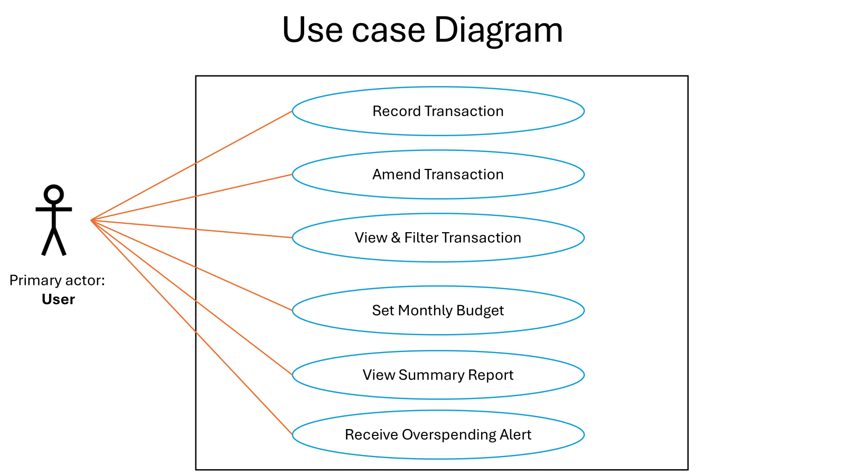

Use-Case Descriptions

UC-1: Record Transaction
- Actor: User
- Goal: Add a new income or expense.
- Preconditions: App is running.
- Main Flow: (1) User initiates adding a transaction. (2) System asks for type, amount, date, category, optional note. (3) User confirms. (4) System saves and updates totals.
- Alternates: Missing/invalid fields → system requests correction.
- Postconditions: Transaction is persisted; summaries reflect it.

UC-2: Amend Transaction
- Actor: User
- Goal: Modify or delete an existing entry.
- Preconditions: At least one transaction exists.
- Main Flow: (1) User selects a transaction. (2) System shows details. (3) User edits or deletes. (4) System saves and refreshes totals.
- Alternates: Entry not found → system informs user.
- Postconditions: History and aggregates reflect the change.

UC-3: View & Filter Transactions
- Actor: User
- Goal: Review past entries by period/category.
- Main Flow: (1) User requests transaction list. (2) System displays entries. (3) User applies filters. (4) System narrows results and updates totals for the selection.
- Alternates: No matches → show empty results and zero totals.

UC-4: Set Monthly Budget
- Actor: User
- Goal: Define or adjust a per-category spending limit for the current month.
- Main Flow: (1) User selects category. (2) System requests limit. (3) User confirms. (4) System stores limit and shows remaining allowance.
- Alternates: Invalid limit → system asks for a valid amount.
- Postconditions: Budgets available to alerts and reports.

UC-5: View Summary Report
- Actor: User
- Goal: See totals and category breakdowns for a period.
- Main Flow: (1) User selects a period. (2) System computes totals and breakdown. (3) System presents figures and at least one chart.
- Alternates: No data in period → system shows zeros and a note.

UC-6: Receive Overspending Alert
- Actor: User
- Goal: Be notified when a category exceeds its limit.
- Preconditions: At least one budget is defined.
- Main Flow: (1) System compares spending to limits as transactions are added/viewed. (2) System signals when a limit is reached or exceeded.
- Alternates: No budgets defined → no alert.
- Postconditions: User is aware of budget status.

Updated User Stories

User Story 1: Record a Transaction
- Description: As a user, I want to record an expense or income so that my daily finances are accurately tracked.
- Traceability: FR1, NFR – Reliability, Usability
- Preconditions: The application is open and the user has access to the “Add Transaction” feature.
- Acceptance Criteria:
- The user can enter transaction details (amount, type, date, and category).
- The transaction is saved immediately after confirmation and appears in the list of transactions.
- The total income/expense summary updates automatically.
- The system provides feedback confirming successful entry.
- Postconditions: Transaction is stored locally and persists when the application restarts.
- Priority: High

User Story 2: Edit or Delete a Transaction
- Description: As a user, I want to edit or delete a transaction so that my financial records stay accurate.
- Traceability: FR1, NFR – Reliability, Usability
- Preconditions: At least one transaction exists in the system.
- Acceptance Criteria:
- The user can open an existing transaction and modify any editable field.
- The user can delete an entry after a confirmation prompt.
- Updated or deleted transactions reflect immediately in totals and summaries.
- The system prevents accidental deletion through a confirmation step.
- Postconditions: Transaction list and totals are updated to reflect the change.
- Priority: High

User Story 3: View and Filter Transactions
- Description: As a user, I want to view and filter transactions by date and category so that I can easily review my spending history.
- Traceability: FR2, NFR – Usability, Performance
- Acceptance Criteria:
- The user can view all past transactions in a table or list.
- The user can filter transactions by category, date range, or keyword.
- The filtered list updates immediately after criteria are applied.
- The user can clear filters to return to the full view.
- Postconditions: Filtered or full lists remain visible until the user changes the view.
- Priority: High

User Story 4: Set a Monthly Budget
- Description: As a user, I want to set a monthly budget for each spending category so that I can manage my expenses more effectively.
- Traceability: FR3, NFR – Usability, Reliability
- Preconditions: User has at least one spending category defined.
- Acceptance Criteria:
- The user can set or update a monthly spending limit for a selected category.
- The budget amount is saved and displayed for the current month.
- The system visually shows remaining budget as transactions are added.
- Invalid inputs (e.g., negative values or empty fields) are rejected with feedback.
- Postconditions: Budget is stored and available for alert and reporting features.
- Priority: Medium

User Story 5: Receive Overspending Alerts
- Description: As a user, I want to receive an alert when spending exceeds my budget so that I can adjust my spending habits early.
- Traceability: FR3, NFR – Reliability, Usability
- Preconditions: At least one active budget is set for the month.
- Acceptance Criteria:
- The system checks total spending against each category limit.
- When spending meets or exceeds the limit, the system displays a clear visual alert.
- The alert indicates the category and amount over budget.
- The alert remains visible until acknowledged or budget is reset.
- Postconditions: User is aware of overspending status and can adjust budgets accordingly.
- Priority: Medium

User Story 6: View Monthly Summary
- Description: As a user, I want to view a summary of my income, expenses, and remaining balance so that I can assess my financial status.
- Traceability: FR4, NFR – Usability, Performance
- Acceptance Criteria:
- The user can select a reporting period (e.g., month or custom range).
- The system generates totals for income, expenses, and balance.
- The summary is displayed in an easy-to-read format.
- When no data is available, a clear “no records found” message is shown.
- Postconditions: Generated summaries can be revisited without re-entry until the user changes the period.
- Priority: High

User Story 7: View Spending Chart
- Description: As a user, I want to see a chart of my spending by category so that I can identify trends and make informed financial decisions.
- Traceability: FR4, NFR – Usability, Performance
- Acceptance Criteria:
- The system presents at least one visual chart (pie or bar) showing spending by category.
- Charts update automatically when transactions or filters change.
- The visualization is easy to interpret with clear labels and legends.
- Postconditions: Chart view remains synchronized with current transaction data.
- Priority: Low

User Story 8: Load Saved Data on Startup
- Description: As a user, I want my saved transactions and budgets to load automatically when I open the app so that I can continue seamlessly.
- Traceability: FR1, FR3, NFR – Reliability, Performance
- Preconditions: Previously saved data exists locally.
- Acceptance Criteria:
- The system loads all stored transactions and budgets automatically at startup.
- The system notifies the user if no data is found.
- Loaded data appears accurately within corresponding views (Transactions, Budgets, Reports).
- Postconditions: User resumes from previous state with no manual loading required.
- Priority: High

Test Plan

Testing Objectives and Scope
The main goal of this testing phase is to make sure that each part of the SmartBudget system works as expected and meets the requirements defined in earlier deliverables. In this iteration, the focus is on preparing the groundwork for testing by defining clear test cases and linking them to each requirement. The testing will mainly cover the system’s core functions such as recording transactions, filtering data, setting budgets, and viewing summaries. Although the tests are not yet executed, this plan ensures that every feature is ready for validation in later stages of development and that the testing process will be organized, consistent, and easy to track.

Testing Approach (Unit Testing Focus for Iteration 3)
The testing approach for this iteration follows a unit testing strategy, where each function or module of the SmartBudget system will be tested individually. This helps identify issues early and ensures that small parts of the program work correctly before being combined into a larger system. The testing plan focuses on designing tests using JUnit in Java to verify calculations, data handling, and interface responses. Each test case will check one small piece of functionality based on the requirements and user stories. Future iterations will expand this to include integration and GUI testing once the main components are implemented.

Requirement-to-Test Case Traceability Matrix
This section shows how each system requirement is linked to one or more test cases. The traceability matrix helps make sure that all functional and non-functional requirements are covered by at least one planned test. It provides a clear view of what will be tested, how it will be verified, and ensures that no part of the system is left untested. This also helps track future changes and maintain consistency between requirements and test documentation.
Table 1: Requirement-to-Test Case Traceability Matrix
Requirement ID | Requirement Description | Test Case ID | Test Case Description | Coverage
FR-001 | Record, edit, delete income/expense transactions; persist locally across sessions | TC-001 | Add expense with valid inputs (amount, date, category, optional note)
FR-001 | — same as above — | TC-002 | Add income with valid inputs
FR-001 | — same as above — | TC-003 | Reject invalid amount (non-numeric / negative)
FR-001 | — same as above — | TC-004 | Reject missing required fields (amount, date, type) with clear feedback
FR-001 | — same as above — | TC-005 | Edit an existing transaction and verify totals update
FR-001 | — same as above — | TC-006 | Delete transaction with confirmation prompt; totals update
FR-001 | — same as above — | TC-007 | Cancel delete preserves the transaction
FR-001 | — same as above — | TC-008 | Data persists across app restart (transactions remain available)
FR-002 | View transactions and apply filters (date range, category) | TC-009 | View all transactions in list/table
FR-002 | — same as above — | TC-010 | Filter by category (single category)
FR-002 | — same as above — | TC-011 | Filter by date range (start–end)
FR-002 | — same as above — | TC-012 | Combined filters (date range + category) narrow results and update totals
FR-002 | — same as above — | TC-013 | No matches → empty results + zero totals shown
FR-002 | — same as above — | TC-014 | Clear filters restores full transaction list
FR-002 | — same as above — | TC-015 | Keyword search narrows list
FR-003 | Set monthly spending limit per category and alert on reaching/exceeding | TC-016 | Set monthly budget (valid positive amount)
FR-003 | — same as above — | TC-017 | Reject invalid budget inputs (negative/blank) with feedback
FR-003 | — same as above — | TC-018 | Update an existing budget; remaining allowance recalculates
FR-003 | — same as above — | TC-019 | Alert triggers when spending equals the limit
FR-003 | — same as above — | TC-020 | Alert triggers when spending exceeds the limit; shows overage amount
FR-003 | — same as above — | TC-021 | No budgets defined → no alert appears
FR-004 | Provide period summary (income, expenses, balance) + at least one chart | TC-022 | Monthly summary totals compute correctly (income, expenses, balance)
FR-004 | — same as above — | TC-023 | Custom range summary computes correctly
FR-004 | — same as above — | TC-024 | No data in selected period → zeros + “no records found” note
FR-004 | — same as above — | TC-025 | Category chart (pie/bar) reflects data accurately with clear labels
FR-004 | — same as above — | TC-026 | Chart and summary auto-update when transactions or filters change
NFR-Usability | Simple, consistent JavaFX UI; clear labels; readable fonts; sensible navigation | TC-027 | Heuristic usability review of labels, font sizes, and navigation between Transactions/Budgets/Reports
NFR-Performance | Responsive under typical datasets; quick loads | TC-028 | Load 1–5k transactions; ensure UI remains responsive (no noticeable lag on list/filter)
NFR-Reliability | Immediate save to local storage; graceful handling of invalid input with clear feedback | TC-029 | Immediate persistence after create/edit/delete; verify storage writes and recovery on restart
NFR-Privacy/Offline | Full offline operation; no network transmission | TC-030 | Run with network disabled; verify all functions work and no network calls are made
NFR-Portability | Runs on Windows, macOS, Linux (supported Java runtime) | TC-031 | Smoke run on 3 platforms; application starts and core flows (add/view) work
NFR-Maintainability | Modular (e.g., MVC) structure; unit tests for core business logic | TC-032 | Project structure review + presence of unit tests for core model/services

Mapping to Use Cases and User Stories
This section connects each test case to the related use cases and user stories. It ensures that all user actions and scenarios described by the users are properly represented in the testing plan. By mapping test cases to these elements, the document confirms that the system will be tested from both technical and user perspectives, covering real-life usage and expected workflows.
Table 2: Mapping Test Cases to Use Cases
Use Case ID | Use Case Goal | Test Case ID(s) | Coverage
UC-1: Record Transaction | Add income/expense and update totals | TC-001, TC-002, TC-003, TC-004, TC-022, TC-026
UC-2: Amend Transaction | Modify or delete an existing entry; refresh totals | TC-005, TC-006, TC-007, TC-022, TC-026
UC-3: View & Filter Transactions | Review by period/category; empty results path | TC-009, TC-010, TC-011, TC-012, TC-013, TC-014, TC-015
UC-4: Set Monthly Budget | Define/adjust per-category limit | TC-016, TC-017, TC-018
UC-5: View Summary Report | Select period; show totals and chart; no-data path | TC-022, TC-023, TC-024, TC-025
UC-6: Receive Overspending Alert | Notify on reach/exceed budget; precondition = budgets defined | TC-019, TC-020, TC-021

Table 3: Mapping Test Cases to User Stories
Use Story ID | Story Summary | Related FR | Test Case ID(s) | Coverage
US-1: Record a Transaction | Add expense or income; immediate save; totals update; success feedback | FR-001 | TC-001, TC-002, TC-004, TC-022
US-2: Edit or Delete a Transaction | Edit/delete; confirmation; totals/summaries update | FR-001 | TC-005, TC-006, TC-007, TC-022
US-3: View & Filter Transactions | View all; filter by category/date/keyword; clear filters | FR-002 | TC-009, TC-010, TC-011, TC-012, TC-014, TC-015
US-4: Set a Monthly Budget | Set/update budget; show remaining; reject invalid | FR-003 | TC-016, TC-017, TC-018
US-5: Receive Overspending Alerts | Trigger at ≥ limit; show category and overage; remains visible | FR-003 | TC-019, TC-020, TC-021
US-6: View Monthly Summary | Select period; totals computed; clear message for no data | FR-004 | TC-022, TC-024
US-7: View Spending Chart | Present chart; auto-updates; clear labels/legend | FR-004 | TC-025, TC-026
US-8: Load Saved Data on Startup | Auto-load transactions/budgets at startup; notify if none | FR-001 /  FR-003 | TC-008

Detailed Test Case Descriptions
This section provides detailed descriptions of all planned test cases that will be used to verify the SmartBudget system. Each test case includes its ID, related requirement, preconditions, steps, and expected results. These details will guide future testing activities, making it easy for developers and testers to perform and track tests systematically once it is implemented.

TC-001
Table 4: TC-01 test case description
Test Case ID | TC-01
Title | Add Expense – Valid Inputs
Requirement | FR-001; UC-1; US-1
Preconditions | App is running; “Transactions” view available
Steps | - Open Transactions; Click “Add Transaction”; Select Expense.  - Enter valid amount (e.g., 25.50), pick a valid date, choose category (e.g., Food), add optional note.  - Click “Save”.
Expected Result | Expense row added; expense increases and balance totals decreases; success feedback; persisted.
Actual Result
Status
Priority | High

TC-002
Table 5: TC-02 test case description
Test Case ID | TC-02
Title | Add Income – Valid Inputs
Requirement | FR-001; UC-1; US-1
Preconditions | App is running; “Transactions” view available
Steps | - Open Transactions; Click “Add Transaction”; Select Income.  - Enter valid amount (e.g., 25.50), pick a valid date, choose category (e.g., Salary), add optional note.  - Click “Save”
Expected Result | Income row added; income and balance totals increase; success feedback; persisted.
Actual Result
Status
Priority | High

TC-003
Table 6: TC-03 test case description
Test Case ID | TC-03
Title | Add Transaction – Reject Invalid Amount
Requirement | FR-001; UC-1; US-1
Preconditions | App is running; “Transactions” view available
Steps | - Open Transactions; Click “Add Transaction”; Select Income/Expense.  - Enter non-numeric (e.g., “abc”) or negative amount.  - Click “Save”.
Expected Result | Save blocked; clear validation message; no record created; no totals change.
Actual Result
Status
Priority | High

TC-004
Table 7: TC-04 test case description
Test Case ID | TC-04
Title | Add Transaction – Reject Missing Required Fields
Requirement | FR-001; UC-1; US-1
Preconditions | App is running; “Transactions” view available
Steps | - Open Transactions; Click “Add Transaction”; Select Income/Expense.  - Leave amount or date or type empty.  - Click “Save”.
Expected Result | Save blocked; specific error message; no changes persisted.
Actual Result
Status
Priority | High

TC-005
Table 8: TC-05 test case description
Test Case ID | TC-05
Title | Edit Transaction – Totals Recalculate
Requirement | FR-001; UC-2; US-2
Preconditions | At least one existing transaction
Steps | - Open an existing transaction.  - Change amount (e.g., 20 → 30).  - Click “Save”.
Expected Result | Row updates; affected totals/summary recalculates; success feedback; persisted.
Actual Result
Status
Priority | High

TC-006
Table 9: TC-06 test case description
Test Case ID | TC-06
Title | Delete Transaction – Confirmation and Totals Update
Requirement | FR-001; UC-2; US-2
Preconditions | At least one existing transaction
Steps | - Open an existing transaction.  - Click delete.  - Confirm deletion.
Expected Result | Row removed; totals/summary recalculates; confirmation used to prevent accidental deletion; persisted removal.
Actual Result
Status
Priority | High

TC-007
Table 10: TC-07 test case description
Test Case ID | TC-07
Title | Delete Transaction – Cancel Preservation
Requirement | FR-001; UC-2; US-2
Preconditions | At least one existing transaction
Steps | - Open an existing transaction.  - Click delete.  - In confirmation, click Cance
Expected Result | No deletion; list and totals unchanged
Actual Result
Status
Priority | Medium

TC-008
Table 11: TC-08 test case description
Test Case ID | TC-08
Title | Persistence – Transactions Survive App Restart
Requirement | FR-001; US-8
Preconditions | At least one existing transaction
Steps | - Close app.  - Reopen app.  - Go to Transactions.
Expected Result | Previously saved transactions load automatically; no manual import required.
Actual Result
Status
Priority | High

TC-009
Table 12: TC-09 test case description
Test Case ID | TC-09
Title | View All Transactions – Default List/Table
Requirement | FR-002; UC-3; US-3
Preconditions | At least one existing transaction
Steps | - Open Transactions view.
Expected Result | All transactions visible in a readable table/list with key columns; totals visible.
Actual Result
Status
Priority | High

TC-010
Table 13: TC-10 test case description
Test Case ID | TC-10
Title | Filter by Category (Single Category)
Requirement | FR-002; UC-3; US-3
Preconditions | Transactions exist across multiple categories.
Steps | - Apply category filter (e.g., Food).
Expected Result | Only rows with category = “Food” shown; totals/summary reflect filtered subset.
Actual Result
Status
Priority | High

TC-011
Table 14: TC-11 test case description
Test Case ID | TC-11
Title | Filter by Date Range
Requirement | FR-002; UC-3; US-3
Preconditions | Transactions exist across multiple dates.
Steps | - Set start and end date.
Expected Result | Only transactions within range shown; totals reflect range.
Actual Result
Status
Priority | High

TC-012
Table 15: TC-12 test case description
Test Case ID | TC-12
Title | Combined Filters – Date Range + Category
Requirement | FR-002; UC-3; US-3
Preconditions | Data spans categories and dates.
Steps | - Apply date range.  - Apply category.
Expected Result | List narrows to intersection; totals update accordingly.
Actual Result
Status
Priority | High

TC-013
Table 16: TC-13 test case description
Test Case ID | TC-13
Title | Filter results – No Matches
Requirement | FR-002; UC-3; US-3
Preconditions | Data set present
Steps | - Apply filters that yield zero results.
Expected Result | Empty list message + zero totals displayed clearly.
Actual Result
Status
Priority | Medium

TC-014
Table 17: TC-14 test case description
Test Case ID | TC-14
Title | Clear Filters – Restore Full List
Requirement | FR-002; UC-3; US-3
Preconditions | Active filter(s) applied.
Steps | - Click “Clear Filters”
Expected Result | All transactions visible again; totals reflect full data set
Actual Result
Status
Priority | Medium

TC-015
Table 18: TC-15 test case description
Test Case ID | TC-15
Title | Keyword Search – Narrows List
Requirement | FR-002; UC-3; US-3
Preconditions | Transactions with varied notes/payee/category names exist
Steps | - Enter keyword (e.g., “coffee”) in search.
Expected Result | Only matching rows shown (by configured fields: note, payee, category); totals update; clearing search restores list.
Actual Result
Status
Priority | Medium

TC-016
Table 19: TC-16 test case description
Test Case ID | TC-16
Title | Set Monthly Budget – Valid Positive Amount
Requirement | FR-003; UC-4; US-4
Preconditions | Category exists (e.g., Food).
Steps | - Open Budgets.  - Select “Food”.  - Enter 200.00.  - Save
Expected Result | Budget stored for current month; remaining allowance visible.
Actual Result
Status
Priority | Medium

TC-017
Table 20: TC-17 test case description
Test Case ID | TC-17
Title | Set Monthly Budget – Reject Invalid Inputs
Requirement | FR-003; UC-4; US-4
Preconditions | Budgets view open
Steps | - Enter negative or blank budget.  - Save
Expected Result | Save blocked; clear error message; no budget created/changed
Actual Result
Status
Priority | Medium

TC-018
Table 21: TC-18 test case description
Test Case ID | TC-18
Title | Update Existing Budget – Recalculate Remaining
Requirement | FR-003; UC-4; US-4
Preconditions | Budget already set for category; some spending exists
Steps | - Edit “Food” budget 200 → 250.  - Save
Expected Result | New limit stored; remaining allowance recalculated and displayed.
Actual Result
Status
Priority | Medium

TC-019
Table 22: TC-19 test case description
Test Case ID | TC-19
Title | Overspending Alert – Trigger at Equal to Limit
Requirement | FR-003; UC-6; US-5
Preconditions | Budget = 100 for Food; current spending = 90
Steps | - Add Food expense of 10.
Expected Result | Alert appears indicating limit reached (category shown); remains visible until acknowledged/reset
Actual Result
Status
Priority | Medium

TC-020
Table 23: TC-20 test case description
Test Case ID | TC-20
Title | Overspending Alert – Trigger when Exceeding Limit
Requirement | FR-003; UC-6; US-5
Preconditions | Budget = 100 for Food; current spending = 95
Steps | - Add Food expense of 10 (total 105).
Expected Result | Alert shows category and overage amount (e.g., +5); persists until acknowledged/reset
Actual Result
Status
Priority | Medium

TC-021
Table 24: TC-21 test case description
Test Case ID | TC-21
Title | No Budget Defined – No Alert
Requirement | FR3; UC-6; US-5
Preconditions | No budgets set.
Steps | - Add multiple expenses in any category.
Expected Result | No budget alert appears.
Actual Result
Status
Priority | Medium

TC-022
Table 25: TC-22 test case description
Test Case ID | TC-22
Title | Monthly Summary – Correct Totals
Requirement | FR-004; UC-5; US-6
Preconditions | Month has known set of incomes/expenses
Steps | - Open Reports.  - Select “This Month”.
Expected Result | Income, expenses, and balance compute correctly and match dataset.
Actual Result
Status
Priority | High

TC-023
Table 26: TC-23 test case description
Test Case ID | TC-23
Title | Custom Range Summary – Correct Totals
Requirement | FR-004; UC-5; US-6
Preconditions | Data across multiple months
Steps | - Choose custom start/end dates across months.
Expected Result | Totals reflect only the selected range; displayed clearly.
Actual Result
Status
Priority | Medium

TC-024
Table 27: TC-24 test case description
Test Case ID | TC-24
Title | Summary – No Data Path
Requirement | FR-004; UC-5; US-7
Preconditions | Select a period with no transactions
Steps | - Open Reports
Expected Result | Zeros shown for totals; clear “no records found” note
Actual Result
Status
Priority | Medium

TC-025
Table 28: TC-25 test case description
Test Case ID | TC-25
Title | Category Chart – Accurate Visualization
Requirement | FR-004; UC-5; US-7
Preconditions | Transactions across multiple categories.
Steps | - Open Reports with chart (pie/bar).
Expected Result | Chart values/percentages match underlying totals; labels/legend are clear.
Actual Result
Status
Priority | Low

TC-026
Table 29: TC-26 test case description
Test Case ID | TC-26
Title | Reports/Charts Auto-Update on Data/Filter Change
Requirement | FR-004; UC-5; US-7
Preconditions | Reports open with visible chart; baseline totals noted
Steps | - Add/edit/delete a transaction OR change filters
Expected Result | Summary and chart refresh immediately to reflect the change.
Actual Result
Status
Priority | Medium

TC-027
Table 30: TC-27 test case description
Test Case ID | TC-27
Title | Usability Heuristics – Labels, Fonts, Navigation
Requirement | NFR-Usability
Preconditions | UI available (Transactions, Budgets, Reports)
Steps | - Inspect labels, font sizes, contrast.  - Walk through navigation paths between key views.
Expected Result | Clear labels; readable fonts; predictable navigation; consistent UI components
Actual Result
Status
Priority | Medium

TC-028
Table 31: TC-28 test case description
Test Case ID | TC-28
Title | Performance – Typical Dataset Responsiveness
Requirement | NFR- Performance
Preconditions | Seed transactions locally
Steps | - Launch app and open Transactions.  - Apply filters/search repeatedly
Expected Result | Loads and interactions complete without noticeable lag; list/filters remain responsive
Actual Result
Status
Priority | Medium

TC-029
Table 32: TC-29 test case description
Test Case ID | TC-29
Title | Reliability – Immediate Save & Graceful Invalid Handling
Requirement | NFR- Reliability
Preconditions | App running
Steps | - Add/edit/delete; immediately kill and relaunch app.  - Attempt invalid inputs on add/edit.
Expected Result | Most recent changes present after relaunch (immediate save); invalid inputs yield clear feedback; no data corruption
Actual Result
Status
Priority | High

TC-030.
Table 33: TC-30 test case description
Test Case ID | TC-30
Title | Privacy/Offline – No Network Dependency
Requirement | Privacy/Offline
Preconditions | Device offline (disable network)
Steps | - Launch app.  - Perform add/view/filter/report flows
Expected Result | All features function offline; no network calls attempted
Actual Result
Status
Priority | High

TC-031
Table 34: TC-31 test case description
Test Case ID | TC-31
Title | Portability – Run on Windows/macOS/Linux
Requirement | NFR-Portability
Preconditions | Build packaged with supported Java runtime
Steps | - Start app on each OS.  - Smoke test add/view flows.
Expected Result | App launches and core flows work on all three platforms
Actual Result
Status
Priority | Medium

TC-032
Table 35: TC-32 test case description
Test Case ID | TC-32
Title | Maintainability – Modular Structure & Unit Tests Present
Requirement | NFR-Maintainability
Preconditions | Repo accessible
Steps | - Review project structure (e.g., MVC separation.  - Verify presence of unit tests for core model/services.
Expected Result | Clear modular separation; baseline unit tests exist; naming/packaging consistent.
Actual Result
Status
Priority | Medium

User Manual

Introduction
SmartBudget is a personal finance tracking application designed to help users record daily transactions, manage monthly budgets, view summaries, and analyze spending patterns. The application operates fully offline, ensures immediate data saving, and supports Windows, macOS, and Linux systems. This manual explains how to use all features of SmartBudget, including:
- Recording, editing, and deleting income or expense transactions
- Browsing and filtering financial history
- Setting category-based monthly budgets
- Receiving automatic overspending alerts
- Viewing summaries and category charts
- Understanding how data is loaded and saved

Getting Started

System Requirements
- Operating Systems: Windows, macOS, Linux
- Java Runtime: Any supported Java runtime compatible with JavaFX
- Network: Not required (SmartBudget functions fully offline)

First Launch
On startup, SmartBudget will automatically:
- Load saved transactions (if any)
- Load monthly budgets (if previously set)
- Display your most recent financial data
If no prior data exists, SmartBudget will inform you that your finance database is empty.

Navigating SmartBudget
The SmartBudget interface consists of four main sections:
- Dashboard - Summary of Total Income, Expenses, Budgets & Recent Transactions
- Transactions – Record, view, filter, edit, and delete income or expense entries.
- Budgets – Set monthly spending limits per category.
- Reports – View summary totals and category charts.

Transactions

Adding a Transaction
You can record either an expense or income.
Steps:
- Open the Transactions tab.
- Click Add Transaction.
- Choose Expense or Income.
- Enter the required details.
- Click Save.

Editing a Transaction
Steps:
- Select a transaction from the list.
- Click Edit.
- Modify amount, category, date, or note.
- Save changes.

Deleting a Transaction
Steps:
- Open the transaction you want to delete.
- Click Delete.
- Confirm deletion in the confirmation prompt.

Viewing Transactions
Displays a table of all entries with totals for income, expenses, and balance.

Filtering Transactions
Filter by:
- Category
- Date range
- Combined filters
- Keyword search
Clear Filters resets the list.

Budgets

Setting a Budget
Steps:
- Open Budgets tab.
- Select a category.
- Enter a monthly limit.
- Save.
- Updating a Budget
Modify the limit and save.

Overspending Alerts
Alerts appear when spending reaches or exceeds the budget limit for a category.

Reports

Summary Report
Steps:
- Open the Reports ab
- Select reporting period:
- This Month
- Last Month
- Custom Range
Reports show totals for income, expenses, and balance.

Category Spending Chart
SmartBudget displays at least one visual chart (pie or bar) broken down by category.
Chart Behaviour:
- Automatically updates when transactions change
- Labels and legends clearly identify categories
- Values correspond exactly to underlying data

Data Persistence
All changes save instantly and load automatically on startup.

Offline Mode and Privacy
SmartBudget works 100% offline. All data remains local.

Performance & Responsiveness
Optimized for large datasets with fast loading and filtering.

Cross-Platform Support
Works uniformly on Windows, macOS, and Linux.

Maintenance & Updates
Modular architecture, clean code structure, and unit test support.

Frequently Asked Questions
Question 1: Does SmartBudget work offline?
Yes, completely offline.
Question 2: Is data synced?
Not in the current version. Data is stored locally on each device.
Question 3: How to back up data?
Manually copy the app's storage folder to another location or device.

Summary
SmartBudget provides a clean, reliable, and intuitive way to:
- Track financial transactions
- Monitor category budgets
- Receive warnings about overspending
- Visualize spending in charts
- Operate securely and offline
This user manual should help you navigate and use all features confidently.

Prototype Overview
This section describes the interactive prototype created for the SmartBudget – Personal Finance Tracker. The prototype was built using Figma and focuses on demonstrating the full user experience of the final application. It does not include backend logic or functional code or even the final UI of the final application. Instead, it presents the visual layout, navigation flow, and screen structure that will guide the development of the real application.
The prototype includes all major features defined in our requirements, use cases, and user stories. It gives a clear view of how users will move through the app and how each feature will look when implemented.

Purpose of the Prototype
The main goal of this prototype is to let users understand the planned interface early in the project. It shows:
- How each feature will appear to the user
- The visual style, layout, and structure of the app
- Main navigation paths between sections
- The expected flow for recording transactions, viewing reports, and setting budgets

Feature Coverage
The prototype includes screens and flows for all key requirements defined in the earlier deliverables:

Record, Edit, and Delete Transactions (FR1)
- “Add Transaction” screen with fields for amount, type, category, date, and notes
- Transaction list showing existing entries
- Edit and delete options displayed within each transaction row

Viewing and Filtering Transactions (FR2)
- A Transactions screen with a clean list layout
- Filter button for selecting category or date range
- Search field for keyword-based filtering
- Clear indicators when filters are active

Monthly Budgets and Alerts (FR3)
- A Budgets screen for setting monthly spending limits per category
- Editable limit field for each category
- Visual indicator for remaining budget
- Alert designs showing overspending warnings

Summary and Charts (FR4)
- Summary screen showing total income, expenses, and balance
- Visual chart (pie or bar) of spending by category
- Option to select monthly or custom periods

Navigation Flow
The prototype follows a simple and intuitive navigation model:
A left navigation bar linking:
- Dashboard
- Transactions
- Budgets
- Reports
This supports the non-functional requirement for usability and ensures easy movement between main features.

Prototype Screenshots

Dashboard view
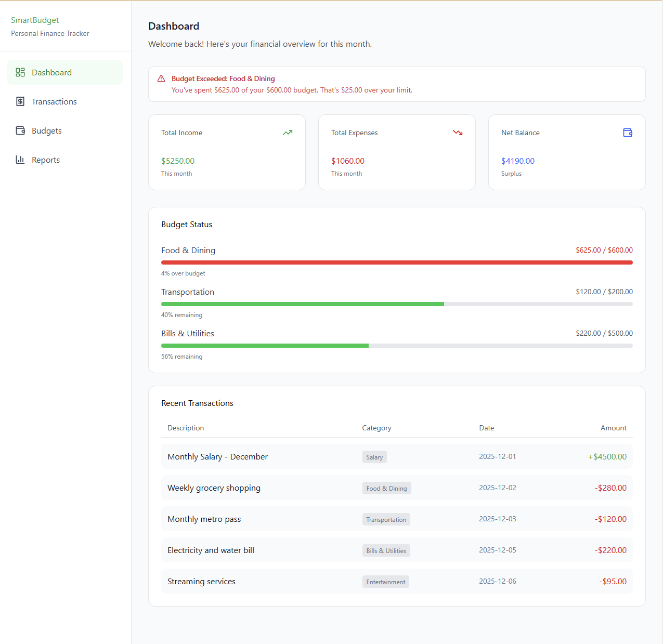

Add Transaction form
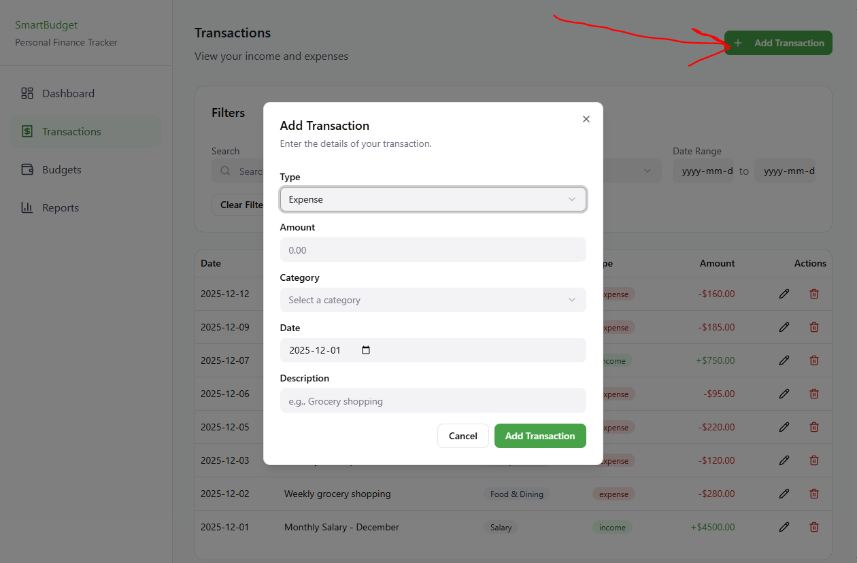

Edit Transaction form
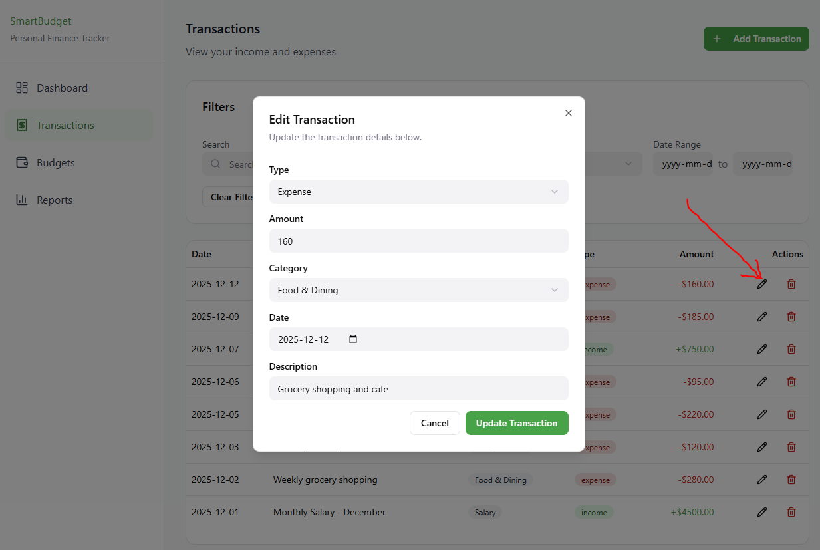

Delete Transaction form
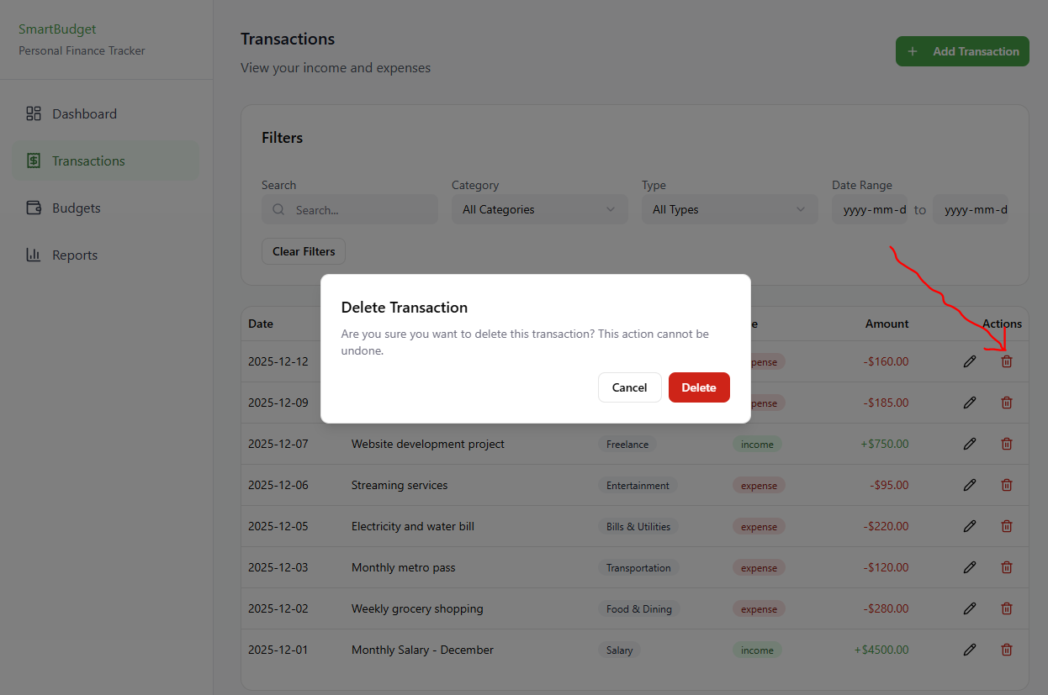

Filters and search UI
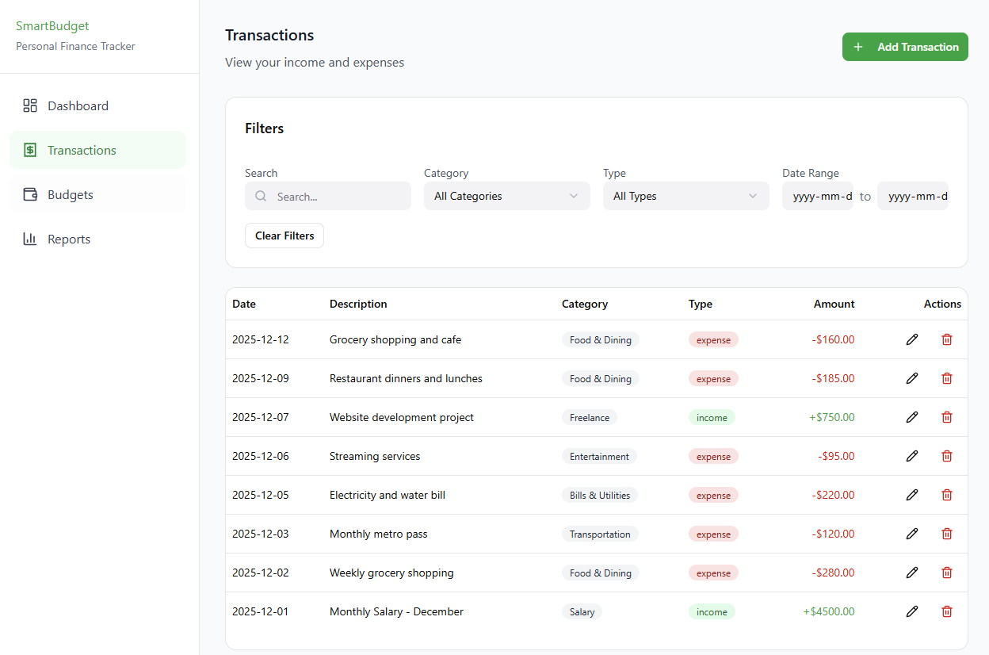

Budgets screen and Overspending alert sample
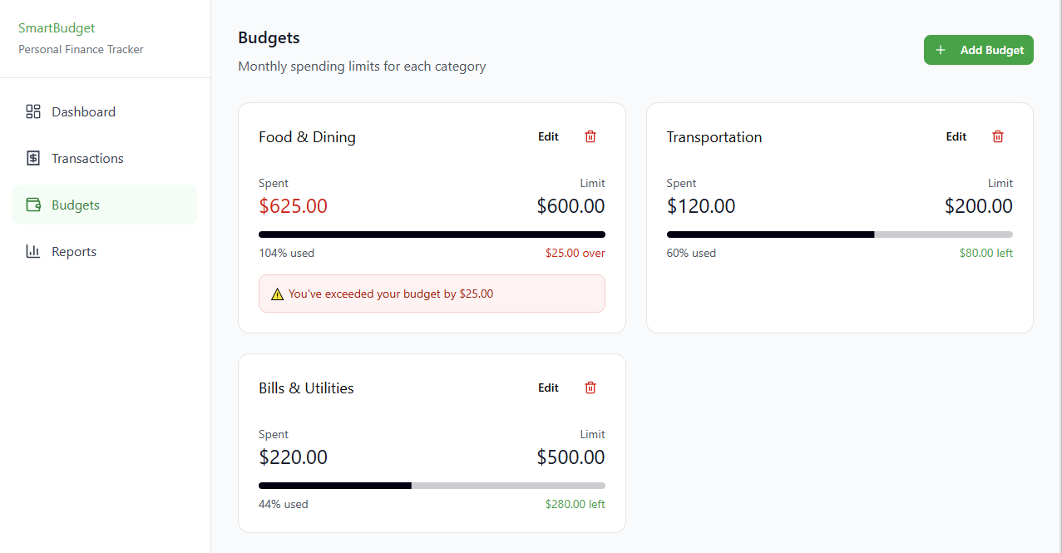

Add Budget form
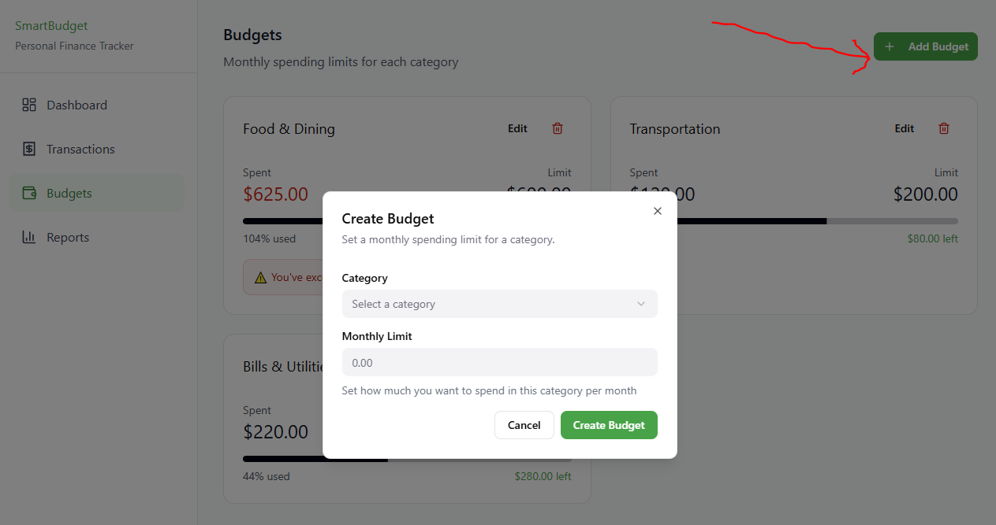

Edit Budget form
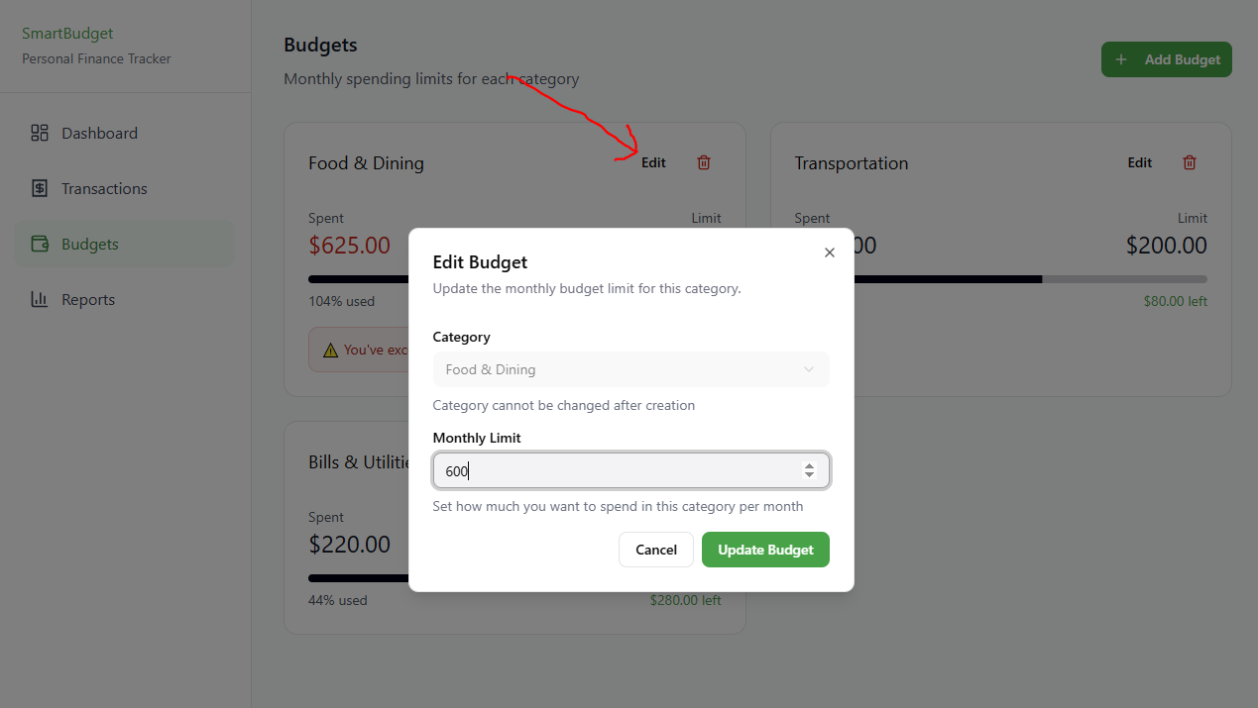

Monthly summary with chart
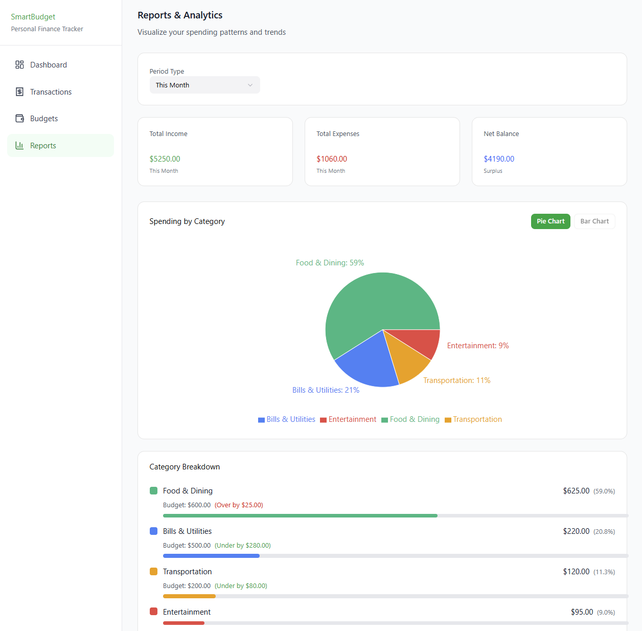

Alignment With Requirements and Testing
The prototype reflects all functional and non-functional requirements documented in Deliverable 2.1. It also supports the testing plan by clearly showing:
- Each interface where a test case action will occur
- Expected UI behaviour (inputs, buttons, messages)
- Visual confirmation of flows covered in the traceability matrix
Although the prototype is not executable, it provides the complete UI foundation needed for implementation in next iterations.

Prototype Link
The full interactive prototype can be viewed here:
https://dandy-wages-80515360.figma.site/

Code Repository and Branching Strategy
The SmartBudget project is hosted on GitHub, and all project deliverables, documents, and source files are stored and updated there throughout each iteration.

Repository Link:
https://github.com/Hercules-Hawk/smart-budget-personal-finance-tracker

Branching Strategy:
For branching, our team follows a simple and organized strategy to keep the code stable while allowing each deliverable to be developed separately. The main branch serves as the stable branch and contains the most reliable version of the project. We do not use a dedicated development branch.
For each deliverable, we create a separate feature branch where we work on the required files for that iteration (for example: docs/deliverable-1.1, docs/deliverable-1.2, docs/deliverable-2.1). After completing the work for a deliverable, the branch is reviewed and then merged into the main branch. This approach keeps the repository organized and ensures that every deliverable is tracked clearly through its own branch, while the main branch always stays clean and stable.

Iteration Plan and Backlog
The SmartBudget project will be developed through multiple iterations across the Fall 2025 and Winter 2026 terms. Each iteration builds upon previous work, aligning with Agile and incremental development principles.

Iteration Plan

Iteration 1 (Weeks 1–2 – Vision and Planning)
- Deliverable 1.1 – Vision Document: Submitted.

Iteration 2 (Weeks 3–5 – Requirements and Use Cases)
- Deliverable 1.2 – Requirements, Use Cases, and User Stories: Submitted.

Iteration 3 (Weeks 6–9 –Testing Document)
- Deliverable 2.1 – Testing Document: Submitted

Iteration 4 (Weeks 10–12 – Mid-Project Peer Review)
- Deliverable 2.2 – Mid Project Report Submission: Current deliverable

Iteration 5 (Weeks 1–2 – Advanced Software Design)
- Deliverable 3.1 – Design Documentation: Class, sequence, and activity diagrams.

Iteration 6 (Weeks 3–4 – GUI Development and Testing)
- Deliverable 3.1 (Update): GUI implementation and initial testing.

Iteration 7 (Weeks 6–9 – Refactoring and Implementation)
- Deliverable 3.2 – Completed Implementation: Refactored, optimized codebase with all core features finalized.

Iteration 8 (Weeks 10–11 – Final Testing and Documentation)
- Deliverable 3.3 – Final Documentation Preparation

Iteration 9 (Week 12 – Block Week – Final Presentation and Submission)
- Deliverable 3.3 – Final Project Submission

Updated Backlog
- User Story 1 – Record a Transaction (Core functionality: enables basic data entry.)
- User Story 2 – Edit or Delete a Transaction (Ensures data accuracy and integrity.)
- User Story 3 – View and Filter Transactions (Viewing is essential for MVP; filtering can be expanded later.)
- User Story 8 – Load Saved Data on Startup (Allows continuity between sessions.)
- User Story 6 – View Monthly Summary (Provides immediate feedback on totals and balances.)
- User Story 4 – Set a Monthly Budget (Introduces budget tracking.)
- User Story 5 – Receive Overspending Alerts (Enhances awareness and control over spending.)
- User Story 7 – View Spending Chart (Adds visualization for deeper insights.)

Conclusion
This deliverable brings together all the work completed so far for the SmartBudget project. In this iteration, we refined the functional and non-functional requirements, updated the use cases and user stories, and completed a full testing document with clear traceability to every requirement. We also added a complete user manual and prepared an updated prototype to guide the future development of the system. The prototype is a UX/UI design created in Figma, and it is not an implementation of the final Java desktop application. Instead, it serves as a visual model that shows how the final system should look and how users will move between features such as transactions, budgets, and reports.
These updates build on the foundation established in earlier deliverables and show steady progress toward developing the actual SmartBudget application. The documentation, test cases, and prototype created here will guide the design and implementation work in the next phases and ensure that development stays aligned with the system requirements.
In the upcoming iterations, we will start moving from planning and design into actual development. The next steps include creating the detailed software architecture, building the JavaFX interface, implementing the core features, and beginning unit testing. As we continue through the Winter 2026 term, we will focus on integration, GUI refinement, performance improvements, and completing the final testing and documentation required for the final submission. Following the Agile workflow and building on the strong base established in this deliverable, we are prepared for the next stages of the project.

